- General
Modul / System | WISE Java Web Application
Tester | Muharrem Ünver
Test Objective  and Scope | General functionality test of the application to decide whether it meets all user requirements.
Test platform | Amazon Web Server  Environment ID: e-hj3zkms8cm  URL: http://sample-env-2.9mgd5ynpdu.us-west-2.elasticbeanstalk.com/homepage.jsp
Test Date | 20.05.2017

Abbreviations:
- maxTweet: Number of tweets to search.
- topTweet: Number of result to Show in result list.
- Test Results
Test No | Test Scenario | Inputs | Expectation | Gained Result | Test Result
1 | Control of the empty city validation  Message. | City: Not selected  Date: 19/05/2017  maxTweet: Integer  topTweet: Integer | A warning message is shown to user to select  a city. | Message box. | Passed
2 | Control of the empty city validation  message. | City: Not selected  Date: Not selected  maxTweet: Integer  topTweet: Integer | A warning message is shown to user to select  a city. | Message box. | Passed
3 | Control of the empty date validation  message. | City: istanbul  Date: Not selected  maxTweet: Integer  topTweet: Integer | A warning message is shown to user to select  a date. | Message box. | Passed
4 | Control of the proper date  validation message. (interval  between today and selected date  must be 9 days at most.) | City: istanbul  Date: 01/05/2017  Today: 19/05/2017  maxTweet: Integer  topTweet: Integer | A warning message is shown to user to select  a sooner date | Message box. | Passed
5 | Control of the proper date  validation message. (selected date cannot  be greater than today.) | City: istanbul  Date: 20/05/2017  Today: 19/05/2017  maxTweet: Integer  topTweet: Integer | A warning message is shown to user to select  a date which is older than today. | Message box. | Passed
6 | Control of the proper date format validation message. (date format  is MM/MM/YYYY) | City: istanbul  Date: 3333  (not selected, 3333333 is written manually)  maxTweet: Integer  topTweet: Integer | A warning message is shown to user to enter  a valid date. | Message box. | Passed
7 | Control of the page redirection with  given proper inputs. | city: ankara  date: 19/05/2017  maxTweet: Integer  topTweet: Integer | Redirect to Result.jsp page with non-empty  Grid. | Result.jsp page with  Filled grid. | Passed
8 | Control of not opening Result.jsp  page manually. | URL: http://sample-env-2.9mgd5ynpdu.us-west-2.elasticbeanstalk.com/result.jsp | Redirect to homepage.jsp | Redirected to  homepage.jsp | Passed
9 | Control of robustness in case of  exceptions. | Searching  without  internet  connection with proper filters. | Not failure of the system. | Empty results | Passed
10 | Control of the empty maxTweet validation message. | City: selected  Date: selected  maxTweet: null  topTweet: Integer | A warning message is shown to user to fill  maxTweet filed. | Message box. | Passed
11 | Control of the empty topTweet validation message. | City: selected  Date: selected  maxTweet: Integer  topTweet: null | A warning message is shown to user to fill  topTweet filed. | Message box. | Passed
12 | Control of the proper maxTweet  parameter format validation  message. (format is Integer) | City: selected  Date: selected  maxTweet: Alfa numeric  topTweet: - | A warning message is shown to user to fill  maxTweet filed with numeric format. | Warning Message | Passed
13 | Control of the proper topTweet  parameter format validation  message. (format is Integer) | City: selected  Date: selected  maxTweet: -  topTweet: Alfa numeric | A warning message is shown to user to fill  topTweet filed with numeric format. | Warning Message | Passed
14 | Control of the proper maxTweet  validation message. (maxTweet  parameter must be 1000 at most.) | City: selected  Date: selected  maxTweet: 1500  topTweet: Integer | A warning message is shown to user to use a smaller maxTweet parameter. | Warning message | Passed

- Screenshots
Test No | Gained Test Result | Expected Test Result (if not passed)
1 | 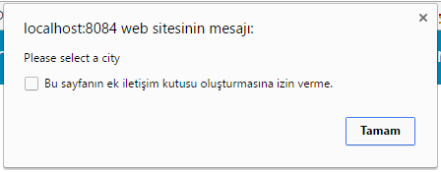
2 | 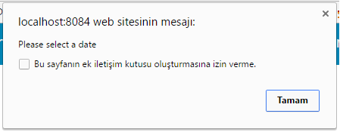
3
4 | 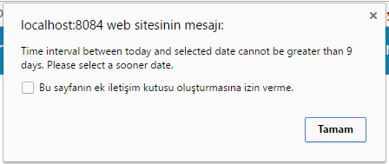
5 | 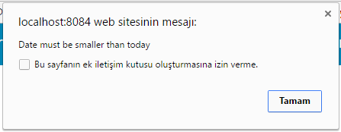
6 | 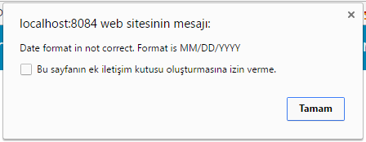
7 | 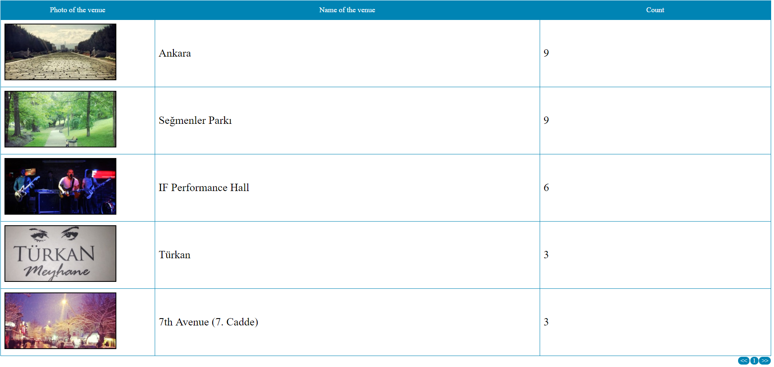
8
9 | 
10 | 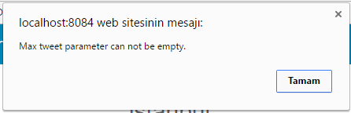
11 | 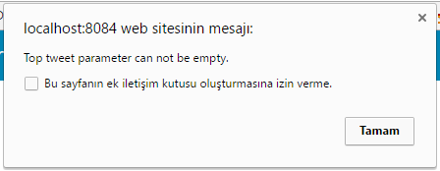
12 | 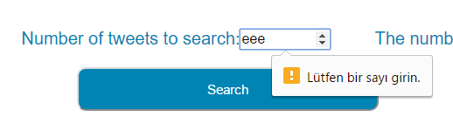
13 | 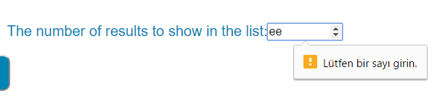
14 | 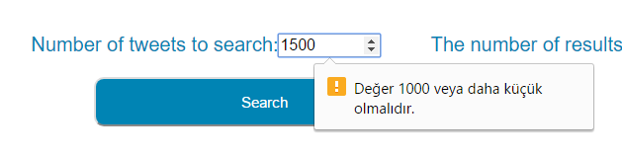
- Conclusion
Tester |  |  | Approver
Name | Date | Signature | Name | Date | Signature
Muharrem Ünver | 19.05.2017

